“Cowtapult” Project and Analysis

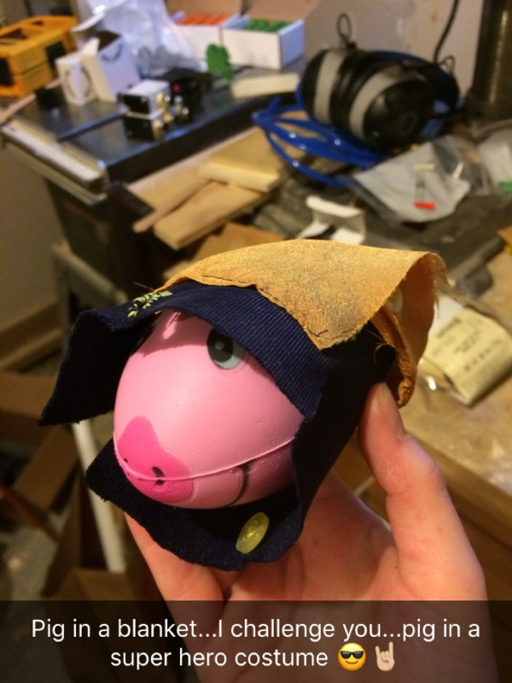 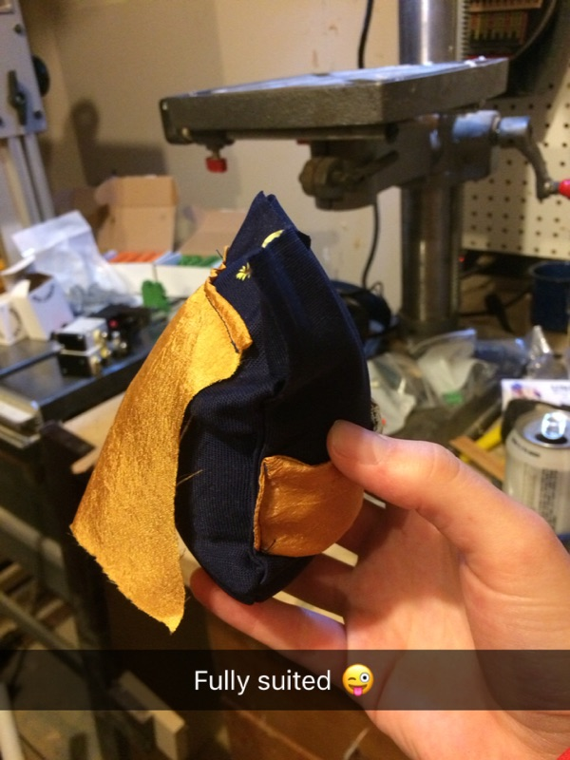

## ME 488

## Design of Experiments

## Fall 2017

### Ryan Crist

### John George

### Marie House

### Greg Sakradse

### Sarah Smith

# Objective

# Executive Summary

# Project Design

### Description

Our “Cow-ta-pult” is modeled after a cross-bow design, using plywood, a drawer guide, a couple of springs, a jack, and a cup. No materials were purchased for this project, all materials were reused from previous assemblies or old projects. The “Cow-ta-pult” has a wooden base with adjustment arms attached that hold up the ramp portion of the design. The adjustment arms have several different cutouts which allow for a change in angle relative to the ground. The ramp is also attached to the base by using two hinges.

The drawer rail guide is attached to the ramp using screws, and is used to propel the ‘pig’ through the air. Attached to the guide is a wood block that is fixed to the cup holding the pig, as well as two springs that are used to move the rail guide. The opposite ends of the springs are attached to the corners of the ramp, creating a situation similar to a rubber band slingshot when the apparatus is pulled back into its launching position.

A strong wooden block is attached at the front end of the rail guide to act as a stop for the slingshot. The ……..

### Factors and Levels

Four factors were selected for this apparatus including change in angle of trajectory, change in payload weight, change in base height, and change in spring position. The initial high and low settings for the change in angle were 60 and 45 degrees from the horizontal. The change in payload weight was determined by adding no additional weight (just the pig weighs an estimated 35 grams), and then adding all the sand that would fit in Mr. Super Piggy’s belt (Figure #), which amounted to roughly 20 grams. The change in base height was determined by a similar method; the minimum was when the apparatus was sitting on the ground, and the maximum at _____ inches after adding blocks to the bottom. Lastly, the spring position was made adjustable by…….

### Concerns (measurable but not controllable)

Since the apparatus was constructed using only scrap material, many concerns began to pop up as the design phase took place. Initially, the quality of material became a concern. Using cheaper plywood resulted in the apparatus quickly disintegrating, so that was swapped for a full-core birch plywood (super strong and durable). This was measurable in a qualitative sense, that the quality of material could be either low, medium, or high and this would affect the rate of depreciation of the equipment. But, the fact remains, the apparatus uncontrollably degrades over.

A measurable concern that did not involve the source of materials, was the shape of the pig. If so desired, it would be possible to calculate the drag force on the pig based on its surface area. It would probably even be warranted to create a simulation of the drag force affecting Mr. Super Piggy as he flew through the air, since there would be a change in surface area normal to the direction of travel creating a small change in the drag force as he flew.

### Concerns (not measurable and not controllable)

Even though the wearing out of the assembly could

* The pig moving around in the cup
  + Also, the way the pig is sitting in the cup initially
* Experimental Design and Procedure
* Wearing out of the assembly
* Cup turning on the block

# Method of Data Collection

Since this is only a four-factor apparatus, it makes sense to use a balanced full factorial design (BFFD).

# Data Collection

* Procedure here
* Include run order table
* Include raw data (“original data sheet”)
* Assumptions validated??
* “Stared Data NOT inappropriately used in analysis”????

# Analysis

# Conclusion

# Challenges

* Maintaining consistency as the system fell a part :P

# Things to do differently next time

* Start with a distance goal and choose materials accordingly? (we seem to do the exact opposite and that seemed difficult)

# Appendices